Module Assembly - TopCoder NodeJS Data Science Challenges API Update Deployment Guide

Revision History
Author | Revision Number | Date
isv | 1.0 | 09/04/2014

Deployment Instructions 3
1. Organization of Submission 3
2. Application Setup 3
2.1 Configuration 3
2.2 Build Scripts Setup 3
3. Database Setup 4
4. Deployment Instructions 4
5. Starting 4
6. Verification 4
7. Resource Contact List 6

Deployment Instructions

Organization of Submission

The submission follows directory structure provided below:

docs

Contains this document which is the Deployment Guide for the Module Assembly - TopCoder NodeJS Data Science Challenges API Update assembly.

tc-api

Contains the configuration, libraries, sources for TopCoder Node JS API application developed/updated in the course of this assembly. This directory replicates the application development distribution structure and includes only updated and new files.

dbscripts

Contains scripts for DB Scripts Tool updated in the course of this assembly.

test_files

Contains files to be used for testing/review purposes only.

Application Setup

The submission is expected to be deployed to the following environment:

JRE 1.7
NodeJS 0.10.21
Informix DS 11.0
Git

This assembly was developed against following Git commit hash:

URL: https://github.com/cloudspokes/tc-api.git
Hash: 349b64fa1163d688cfbdcbef29694bdccbf480a9

The DB Scripts Tool scripts have been updated agains following SVN revision:

URL: https://coder.topcoder.com/internal/database/scripts/trunk
Revision: 85120

Configuration

No new configuration parameters have been defined by this assembly.

Build Scripts Setup

The TopCoder NodeJS API application provides the following commands which are to be used:

- npm install – installs TopCoder NodeJS API application
- npm rebuild – rebuilds TopCoder NodeJS API application
- npm test – runs Mocha-based unit tests.

Database Setup

Execute test_files/db_update.sql script to alter the database for the needs of this assembly. That script will create new view against TCS_DW and TOPCODER_DW database tables.

Deployment Instructions

- Set up necessary infrastructure for TopCoder NodeJS API based on your environment See following page for details (click the link corresponding to your OS):
  - https://github.com/cloudspokes/tc-api/wiki/_pages
- Clone TopCoder NodeJS application from Git repository https://github.com/cloudspokes/tc-api.git to your local machine. See chapters suitable for your local environment at following page for details (click the link corresponding to your OS):
  - https://github.com/cloudspokes/tc-api/wiki/_pages
- Checkout the TopCoder NodeJS application commit referenced by hash specified by section 2 of this guide (use git checkout command)
- Copy the code from tc-api directory of this submission into working copy cloned from Git repository at step above
- Set up environment variables to suit the current environment. See https://github.com/cloudspokes/tc-api/wiki/Configure-Environment-Variables
- Install TopCoder NodeJS API application using npm install command. See chapters suitable for your local environment at https://github.com/cloudspokes/tc-api/wiki/_pages for help (click the link corresponding to your OS)

Starting

- Install the TopCoder NodeJS API application
- Start ActionsHero server instance hosting TopCoder NodeJS API application (see Start Server chapter at page matching your current OS at https://github.com/cloudspokes/tc-api/wiki/_pages)

Verification

- Setup node-jslint tool using command like npm install jslint -g and check formatting for the updated code using commands like:

jslint -nomen actions/dataScienceChallenges.js
jslint -nomen test/test.dataScienceChallenges.js
jslint routes.js
jslint initializers/helper.js

There must be no code formatting errors displayed (except of few errors in helper.js which are not caused by this assembly):

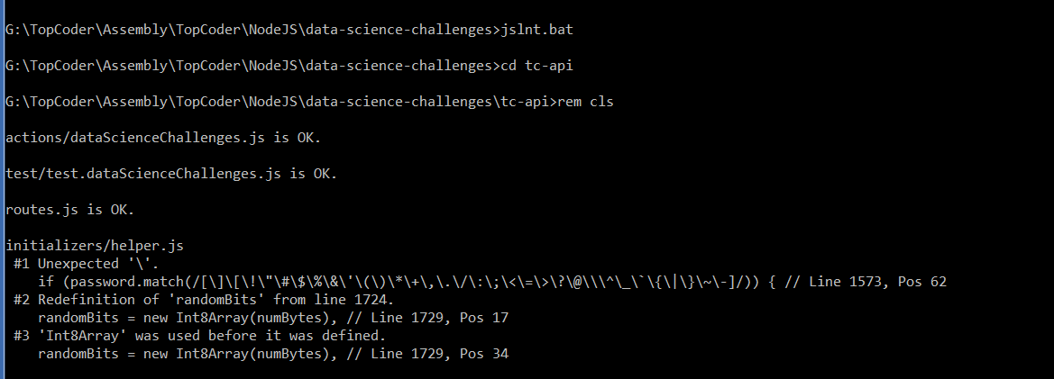

- Run the unit tests using command like:

node_modules/.bin/mocha ./test/test.dataScienceChallenges.js

The tests must be executed successfully:

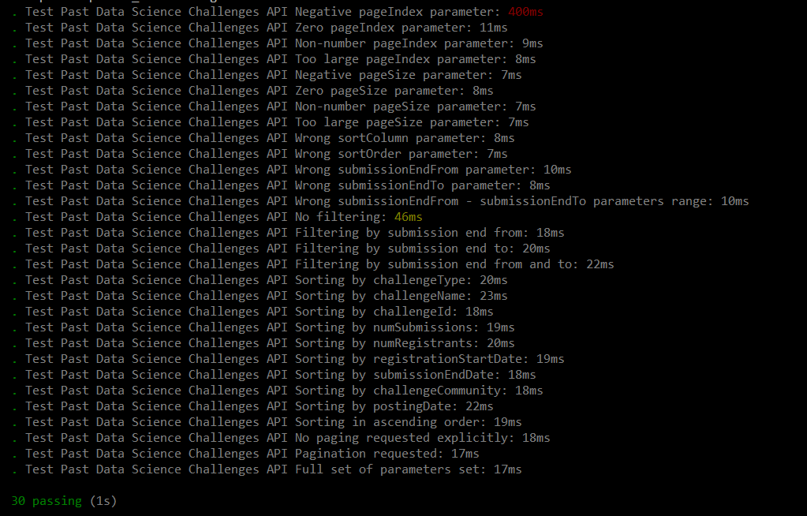

- Open browser window and hit the Past Data Science Challenges API endpoint (you may run test_files/sample_data.sql script to set some challenges)

The service must respond successfully:

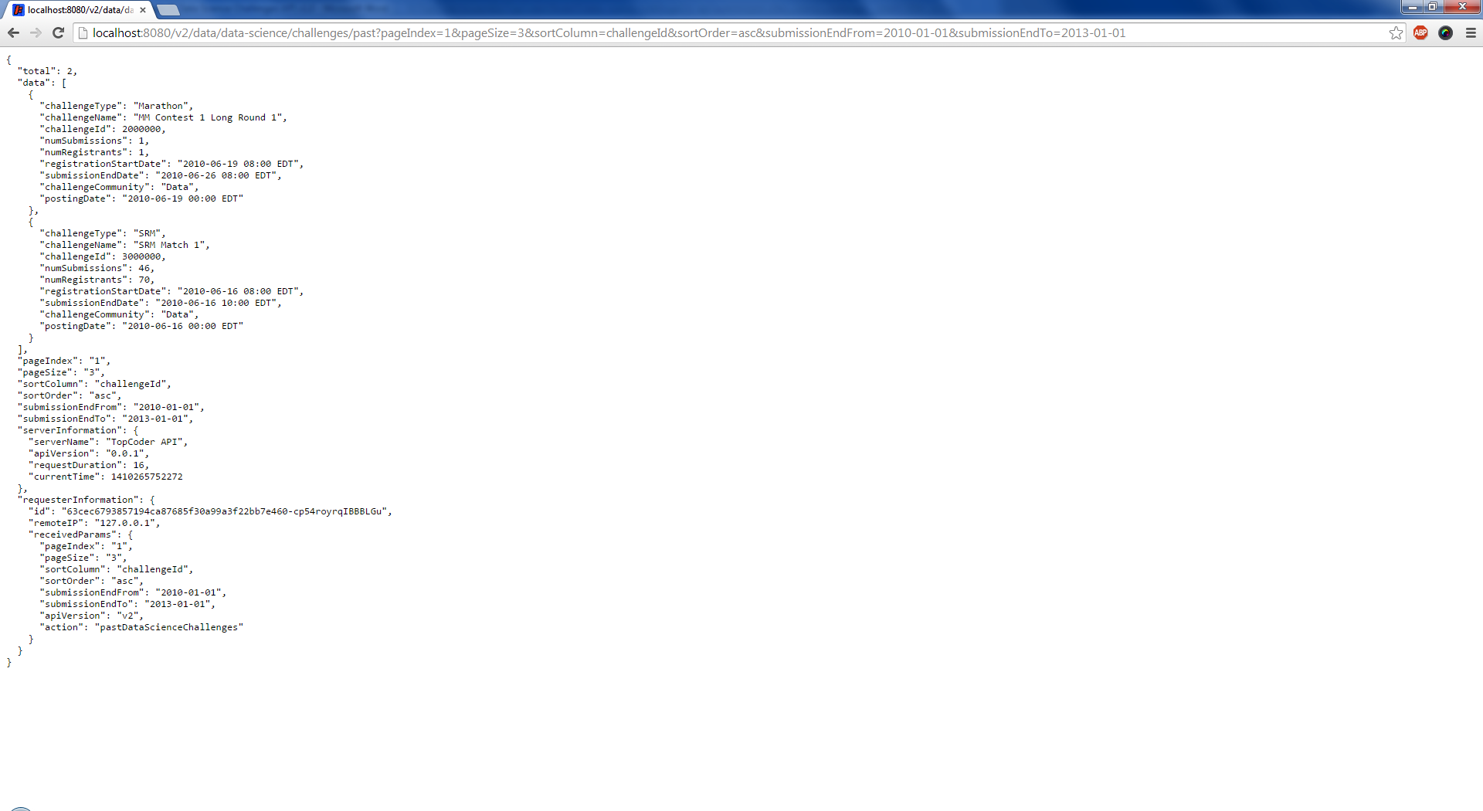

Resource Contact List

Name | Resource Email
isv

